# CSC570 NoSQL Databases

# Lab 1, Part 1: Graph Database / Neo4j

## Graph Databases:

The final type of NoSQL datastore we will study is called a graph database. As the name implies, it stores data as a graph (in the mathematical sense). It’s known for being “whiteboard friendly,” meaning if you can draw a design as boxes andlines on a whiteboard, you can store it. Graph databases focus on the relationships between values rather than on the commonalities among sets of values (such as collections of documents or tables of rows). In this way, it can store highly variable data in a natural and straightforward way.

### Why Neo4j:

Neo4j is small enough to be embedded into nearly any application. On the other end of the spectrum, Neo4j can store tens of billions of nodes and as many edges. And with its cluster support with master-slave replication across many servers, it can handle most any sized problem you can throw at it

### Starting Neo4j:

You have a local Neo4j server on your Neo4j VM. You need to start it first by double clicking the Neo4j Community Edition icon on your desktop and selecting Start. (Leave the database location as is).

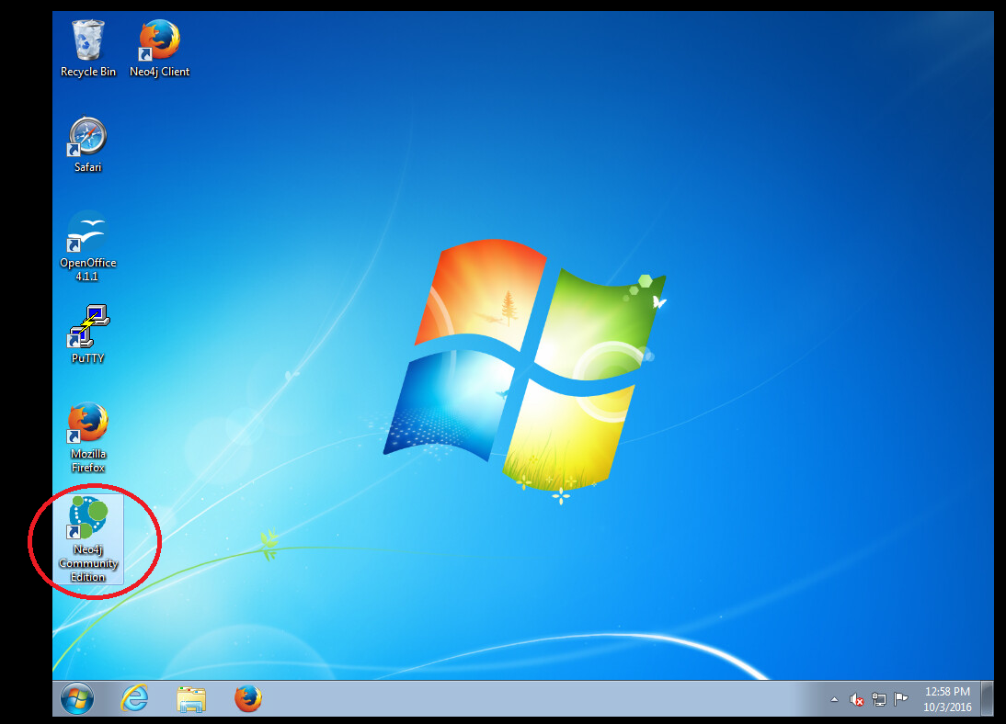

It may take a minute to launch the server. You will see a yellow staus message as it sets up the database:

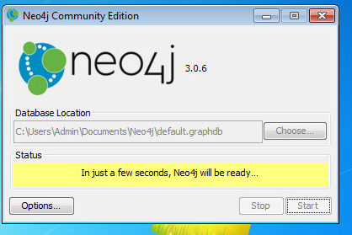

When it is ready, the status will change to green:

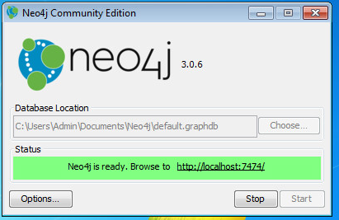

You can minimize the server window now (DO NOT CLOSE IT, just minimize it).

With your server now running, launch the Neo4j web client from the icon on your desktop. It will take you to localhost:7474/browser/ :

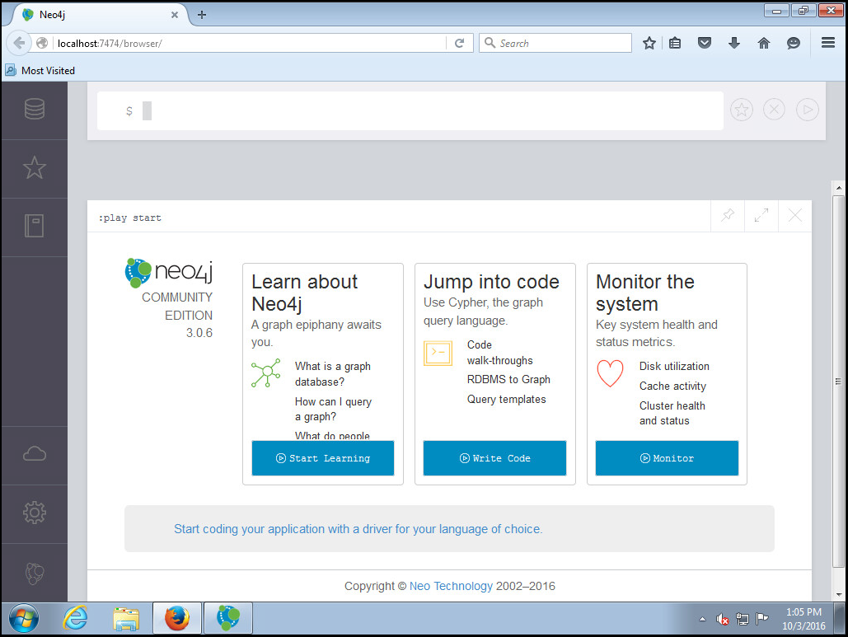

Neo4j comes pre-packaged with great resources and tutorials. It also includes the Graph query language Cypher pre-installed and ready to use.

The first thing we have to do is connect to a database. If you click on the “:server connect” in the blue bar (or type it in the command bar at the top of the page where the $ is), you will be taken to the login routine to establish a connection. The initial default user and password are neo4j/neo4j.

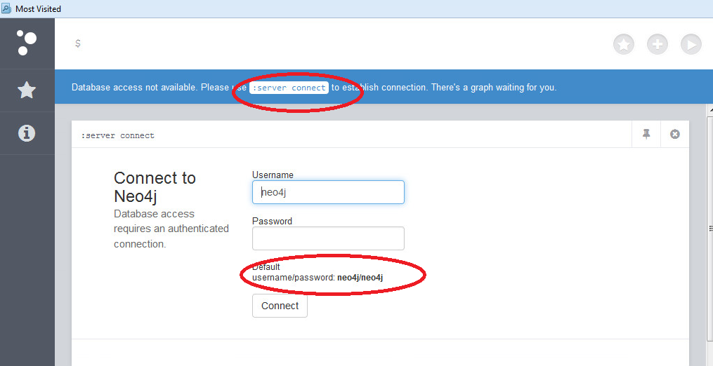

When it prompts you to change the password, please enter our usual password of p@ssw0rd

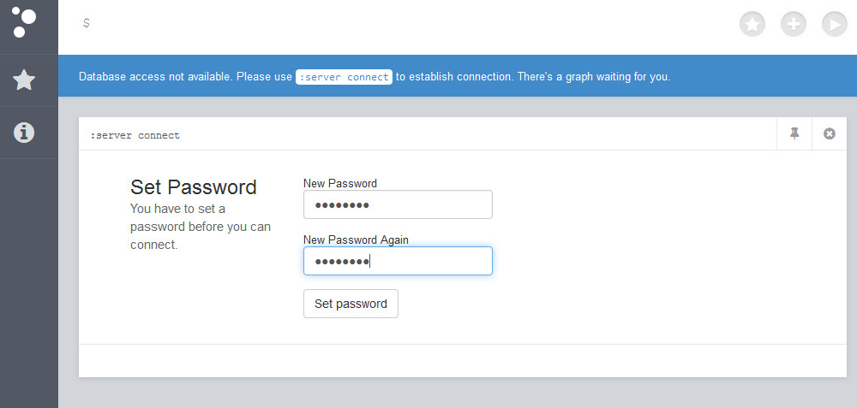

If you click the Documentation “book” icon on the left sidebar, you will have access to 3 great slideshow guides for Neo4j:

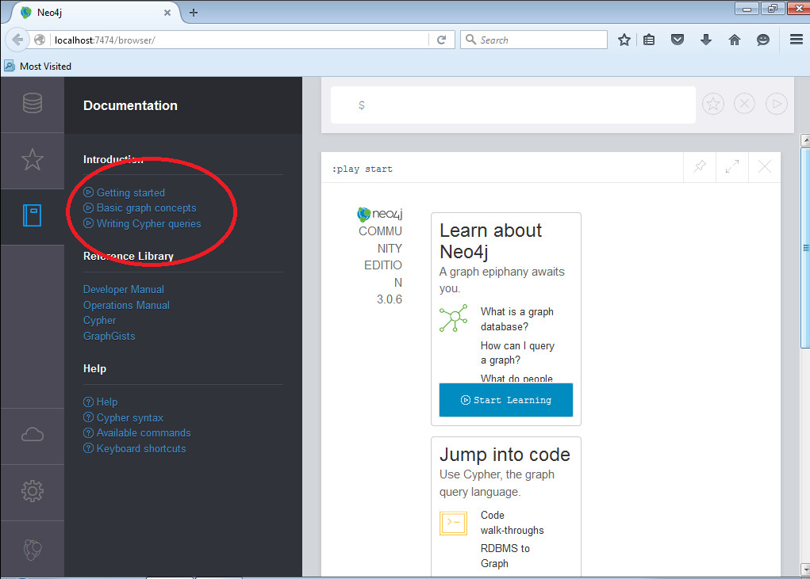

These guides contain everything you need to get you started, so take the time to work through them (they are not very long).

When you get to the Cypher code guide, you can click in any of the code windows to copy the guide code into your command window to run the sample: 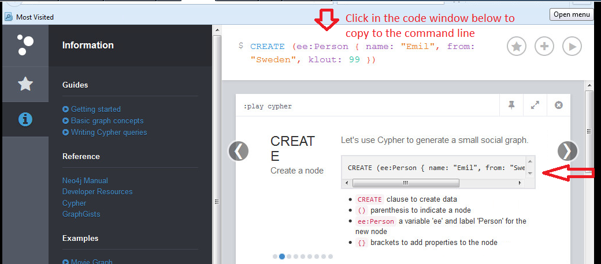

You then press the play button on the command line to execute the code. Neo4j will open a window within your workspace frame and display the results: 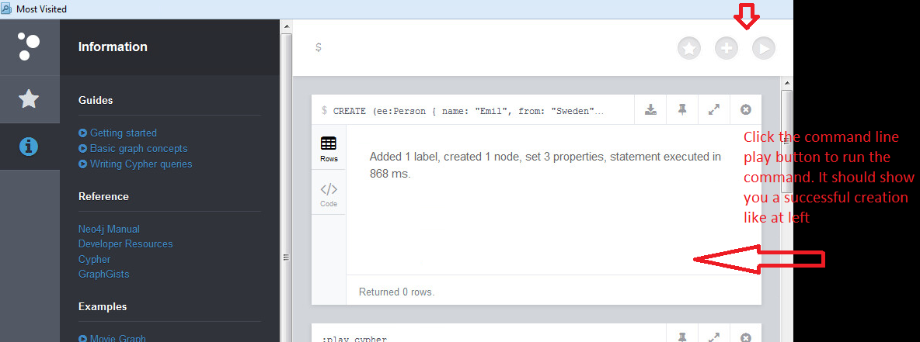

As you work through this code tutorial, Neo4j will display the graph results of your queries: 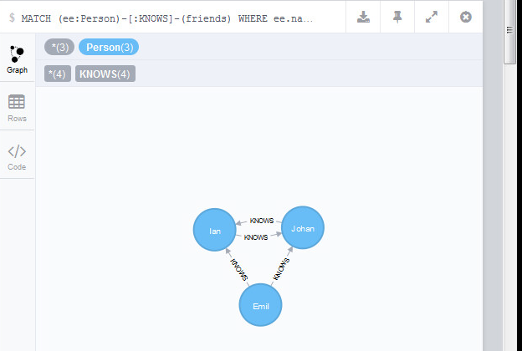

In addition to the intro guides, Neo4j comes packaged with two nice sample graphs, Movie and Northwinds, and a selection of query templates.

**CONTINUE TO NEXT PAGE FOR WORK TO SUBMIT**

### Work on your own to submit

1. In the “Sample Scripts” , select the Example Graphs and work through the Movie Graph Example found here:

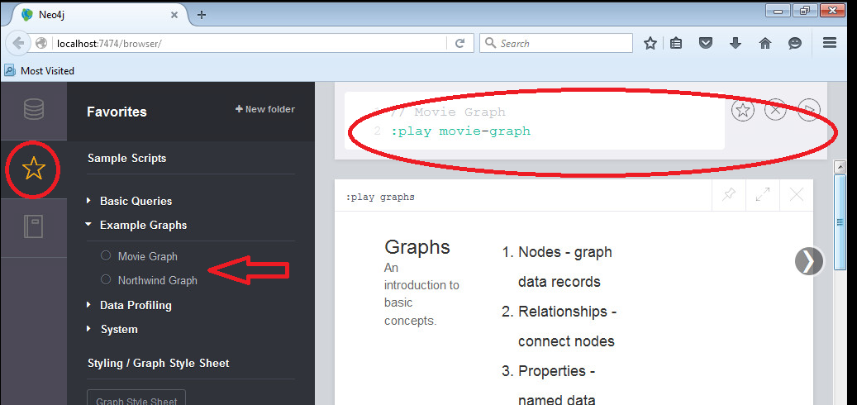

Take screen shots of the following:

* 1. Result graph from your create statement
  2. Results returned from your Find queries
  3. Results returned from your pattern queries
  4. Your solution to the Bacon Path

1. Create a new graph that represents your family. Submit a screenshot of your graph.